Table of Contents

１ Abstract 3

２ Prerequisite 3

３ Components 3

(1) Functions of the server side plugin 3

I. Automatic Numbering 3

(2) Functions of the RTC Eclipse Client plugin 3

I. Configuration of the number of digit 3

II. Additional numbering key with custom attributes 4

III. On & Off control 4

IV. Validating the configuration of “Workitem Number attribute” 4

４ How to use 4

(1) Install 4

I. Preparations 4

II. Server plugin installation 4

III. RTC Eclipse Client plugin 7

IV. Check the installation status of the plugin 8

(2) Setting 10

I. Add Workitem Number attribute 10

II. Configuration of automatic numbering function 12

(3) Synchronize Attributes of existing workitems 14

５ Properties of this feature 15

(1) Properties 15

I. Plugin common properties 15

II. RTC Eclipse Client plugin 15

(2) How to change properties 16

I. RTC Server plugin 16

II. RTC Eclipse Client plugin 16

６ Hint&Tips 17

(1) About the automatic numbering mechanism 17

I. In case of changing the work item type 17

II. In case of changing custom attribute in numbering key 17

(2) About numbering of work item which was created before this feature was enabled 17

### Abstract

In Rational Team Concert(RTC), the workitem ID is assigned as the unique identifier of workitems. However this identifier is unique in the RTC server, so it’s not sequential in each project area and awkward for workitem management.

The workitem numbering follow-up action resolves this problem. This feature number the unique identifier by workitem type of the project area and save it as Work Item Number (Custom attribute).

### Prerequisite

* High Availability configuration is not supported
  + This feature place the final number of Workitem Number in the cache for performance improvement. Therefore, this feature does’n work correctly with high availability configuration
* This plugin is created and tested with RTC-SDK v4.0.5 only.

### Components

This feature consist of one server side plugin and one client side plugin.The server side plugin automatically numbers Workitem Number and the client side plugin is for configuration of this feature.

#### Functions of the server side plugin

##### Automatic Numbering

This plugin automatically number the unique identifier by workitem type of the project area. This unique identifier is sequential in each workitem type.

###### Automatic Roatation of Workitem Number

When the final Workitem Number reaches the max value with the number of digit which is configured in “Configuration of the number of digit”,the next Workitem Number is set to “1” again.

Avoiding duplication of Workitem Numbers, set the number of digit larger.

#### Functions of the RTC Eclipse Client plugin

##### Configuration of the number of digit

To be usefu in the listing of workitems, this plugin supports zero-padding.

For instance, the number of digit is “5”, Workitem Number is assigned “00001”,”00002”,”00003” in order.

Options for the number of digit is mutable with the configuration file for this plugin.In default configuration is “5-digit” or “10-digit” or “15-digit”.

##### Additional numbering key with custom attributes

Normally, Workitem Number is numbered by workitem type of the project area. When this workitem has some custom attributes, these custom attributes is available for the additional numbering keys

For instance, When “Defect” workitem type has “al phase”, “causal phase” is available for the additional numbering key. And Workitem Number is numbered by “causal phase”.

##### On & Off control

###### On & Off control for the server plugin

This plugin is controlled with the process configuration of the project area because this plugin extends the follow-up action feature.

###### On & Off control for the target workitem type

The project area editor is available for On & Off control for the target workitem type. For additional information, refer “Configuration of target workitem types”

##### Validating the configuration of “Workitem Number attribute”

It is a validation function for the configuration of “Workitem Number attribute”. When the attribute isn’t configured in a workitem type correctly, this plugin don’t allow users to turn on the feature with that workitem type.

### How to use

#### Install

##### Preparations

###### Unzip the archive files

Unzip the archive files and check the contents in the unzipped folder.

* + - Server plugin

<unzipped folder>\server\jp.jp_life.jpsol.rtcaddon.workitem.service.updatesite

* + - Client plugin

<unzipped folder>\client\plugins

##### Server plugin installation

###### Make the update site directory for the server plugin

Make a directory in the update site directory under the RTC server install directory.

例）When <RTC server install directory> is C:\IBM\JazzTeamServer,

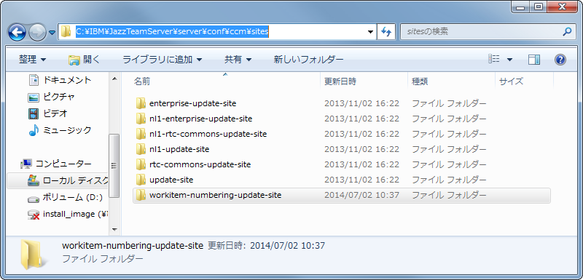　 make a directory under C:\IBM\JazzTeamServer\server\conf\ccm\site

###### Copy plugin libraries

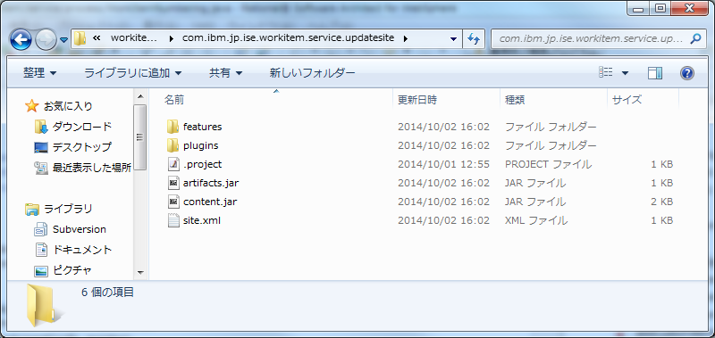Copy feature folder, plugins folder and site.xml from unzipped folder to the directory which is made by “Make the update site directory for the server plugin”.

###### Create provisioning ini file

Create the ini file in provision_profiles directory of the CCM application under the RTC server install directory.

例） When <RTC server install directory> is C:\IBM\JazzTeamServer,

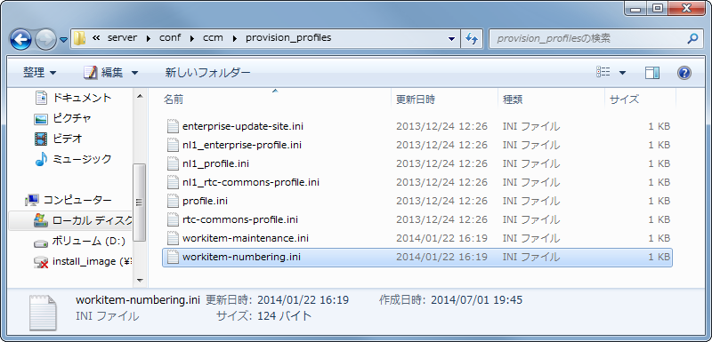　 create an ini file under

C:\IBM\JazzTeamServer\server\conf\ccm\provision_profile

Edit ini file as follows,

url=file:ccm/sites/workitem-numbering-update-site

featureid=com.ibm.jp.isen.workitem.service.feature

###### Submit a request for resetting to the RTC server

Access the following URL and submit a request for resetting to the RTC server.

https://<FQDN>:9443/ccm/admin/cmd/requestReset

The RTC server will load the ini file which is edited in ”Create provisioning ini file” and the server plugin will be installed.

* When the RTC server is installed in a Tomcat server, the RTC server will also load the ini file by deleteing the following directory.

例） When <RTC server install directory> is C:\IBM\JazzTeamServer,

　delete C:\IBM\JazzTeamServer\server\tomcat\work\Catalina\localhost\ccm

###### Restart the RTC server

Restart the RTC server.

###### Check the provisioning status

Access the following URL and confirm the provisioning status of the RTC server.

https://<FQDN>:9443/ccm/admin?internal=true#action=com.ibm.team.repository.admin.provisionStatus

If the plugin was installed correctly, you can find the following message in theprovisioning status.

CRJAZ0303I The profile install from "file:ccm/sites/workitem-numbering-update-site" was started at "Wed Jul 02 10:54:16 JST 2014".

CRJAZ0300I This feature is being installed: "com.ibm.jp.ise.workitem.service.feature_1.0.0. 201410021602"。

CRJAZ0299I Installing bundle from the URL "file:/C%3a/IBM/JAZZTE~/server/conf/ccm/sites/workitem-numbering-update-site/plugins/jp.jp_life.jpsol.rtcaddon.workitem.common_1.0.0.201410021602.jar".

CRJAZ0299I Installing bundle from the URL "file:/C%3a/IBM/JAZZTE~3/server/conf/ccm/sites/workitem-numbering-update-site/plugins/jp.jp_life.jpsol.rtcaddon.workitem.service_1.0.0.201410021602.jar".

##### RTC Eclipse Client plugin

*Only users who configure this feature have to do the following install task.With the correct configuration, if users who does’n install the client plugin create new workitem, Workitem Number will be also numbered.

###### Make the directory for manual plugin install

Make the dropins directory under the RTC Client install directory.

例）When <RTC Client install directory> is C:\IBM\TeamConcert,

　 make C:\IBM\TeamConcert\dropins.

If the RTC Client is integrated with other Eclipse products, it might already exist.In that case, don’t need to make it.

###### Copy plugin libraries

Copy the unzipped folder of the client plugin at “Unzip the archive files” into the directory which is made at “Make the directory for manual plugin install”.

###### Restart RTC Eclipse client

Restart RTC Eclipse client

##### Check the installation status of the plugin

###### Check the installation status

Connect any project area with Eclipse Client.

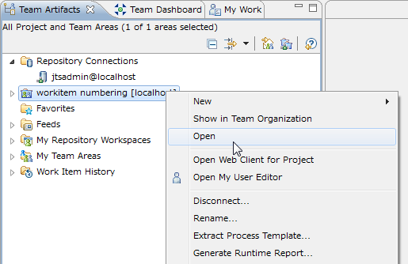Select “Open” from the context menu of the project area, and then the project area editor will be opened.

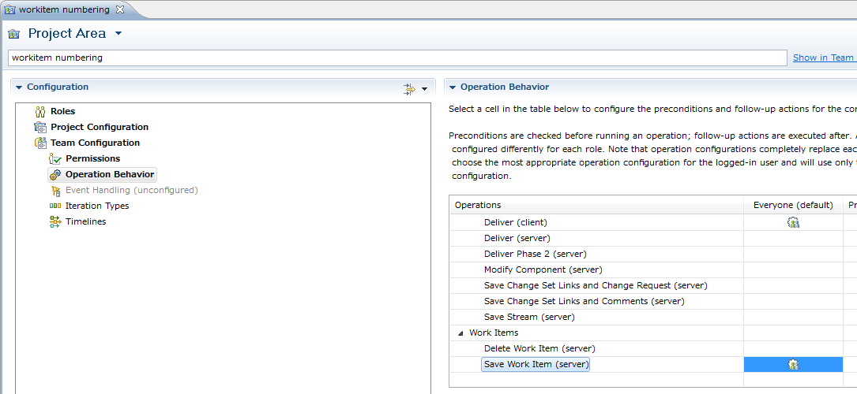Select “Process Configuration” tab and select “Operation Behavior” under the “Team Configuration” in “Configuration” section. In “Operation Behavior” section, find “Save Work Item (server)” and “Everyone (default)” and select the crossing cell.

Click “Add” button at the “Follow-up actions” configuration area below the table, if “Workitem Numbering” is listed in the “Add Follow-up Actions” dialog the server plugin is installed correctly.

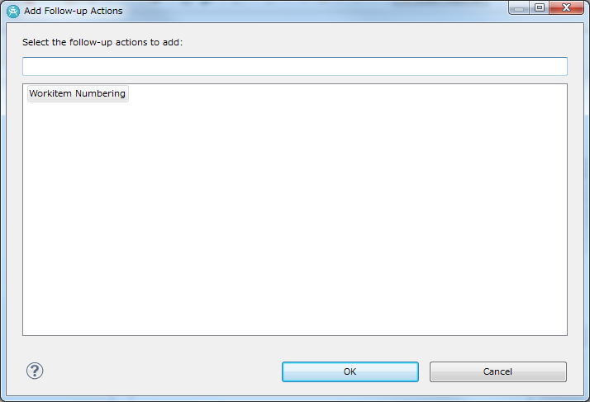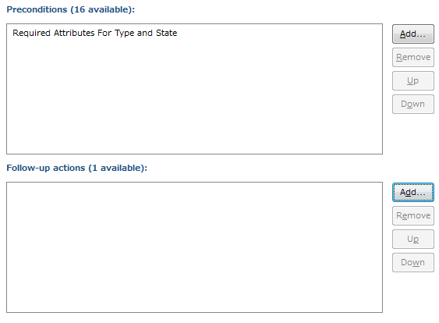Then, select “Workitem Numbering” in the “Add Follow-up Actions” dialog, if the configuration options is displaye, the client plugin is also installed correctly.

If “Add” button is grayout, check “Preconditions and follow-up actions are configured for this operation”

#### Setting

##### Add Workitem Number attribute

Open the project area editor with the same process in “Check the installation status”.Select “Process Configuration” tab and select “Types and Attributes” under the “Project Configuration -> Configuration Data -> Work Items” in the “Configuration” section.

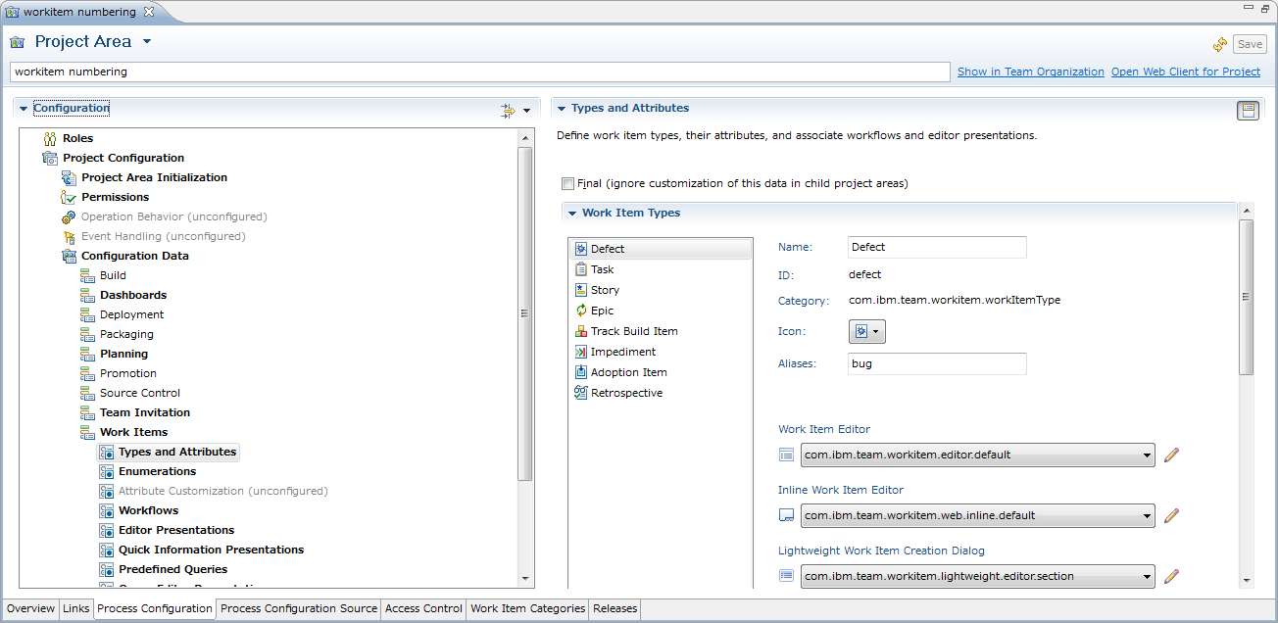 Select a target work item type of this feature, click “Add” button located on the right side of the table in “Attributes” section.

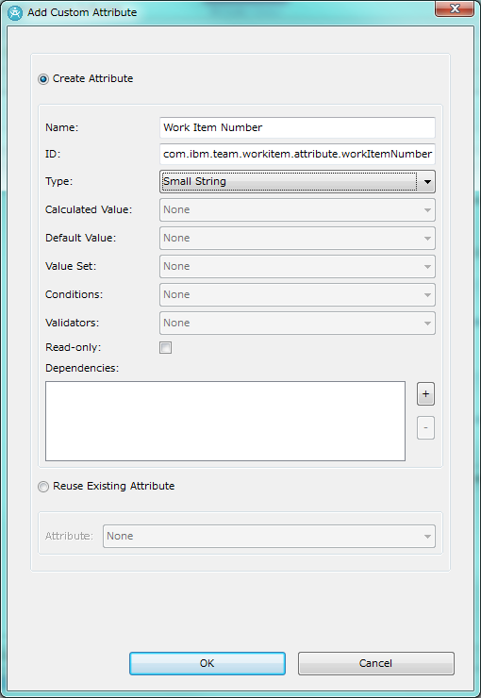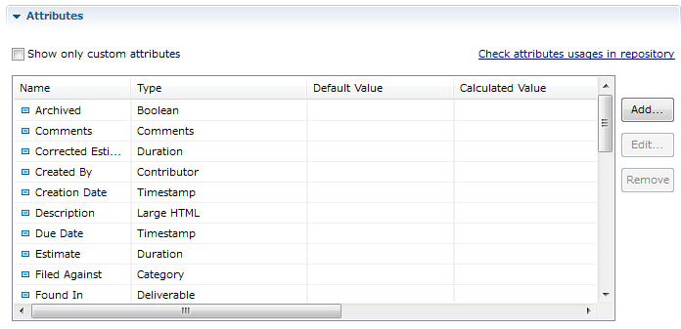

Select “Create Attribute” check box in “Add Custom Attribute” dialog and set each items as follows.

Name:Work Item Number

ID: com.ibm.team.workitem.attribute.workItemNumber

Type:Small String

If the above ID is already used in your project area, change the value of Workitem Number Attribute ID which is mentioned in “Properties of this feature” and re-install both server plugin and client plugin to use a different ID.

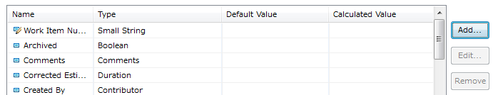Check Work Item Number attribute was added in the table of Attributes.

For other work item types, add Workitem Number attribute with the following process.

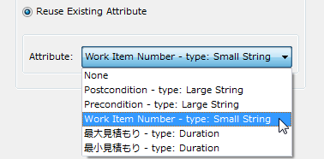Select next work item type in “Work Item Types” selection and click “Add” button located on the right side of the table in “Attributes” section.

Select “Reuse Existing Attribute” check box in “Add Custom Attribute” dialog and select “Work Item Number” from “Attribute” list box.

Add Workitem Number attribute to other work item types with the same process.

##### Configuration of automatic numbering function

###### Add “Workitem Numbering” to the operation behaviors

Add “Workitem Numbering” to “Save Work Item” operation with the same process in “Check the installation status”

###### Configuraiton of the number of digit

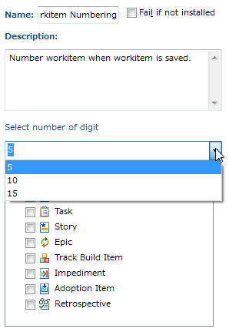 Select the number of digit from list box.

*In default configuration, options are “5”,”10”,”15” only. You can change these options to change the configuration of “Number of digit” and re-install client plugin

###### Configuration of target workitem types

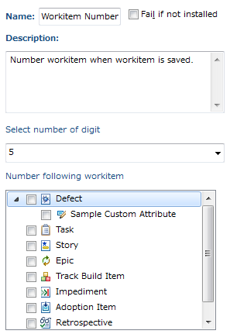

Select target work item type from the check box tree.

If a work item type has a **custom attribute** which is supported by this feature, it is displayed as child element under the type.

If you want to number by work item type, you have to select work item type check box only.

If you want to number by work item type and some custom attributes, your have to select work item type and some custom attributes.

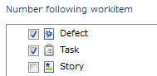Ex) “Defect” and “Task” is target and number by work item type.

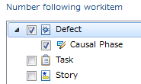

Ex）”Defect” is target and number by work item type and “Causal Phase” attribute.

“Causal Phase” of “defect A” is “SIT” and “Causal Phase” of “defect B” is “UAT”. Both workitems are numbered “00001”.

#### Synchronize Attributes of existing workitems

Synchronize Attributes with following process because workitems was created before enabling this feature don’t have Work Item Number attriubute.

###### Create work item query

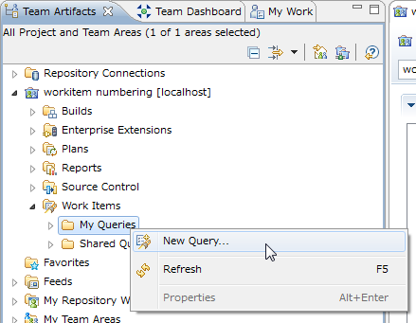Select “New Query” from the context menu of “My Queries” under “Work Items” in “Team Artifacts” view.

And then, the work item query editor is opened, click “Run” button located on the top-right, and all work items in the project area is listed in “Work Items” view.

###### Synchronize additional attribute

Select synchronizing target work items and select “Synchrozie Attributes” from the co

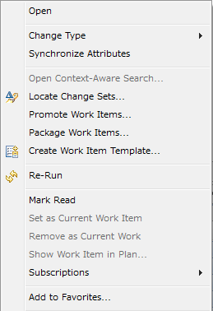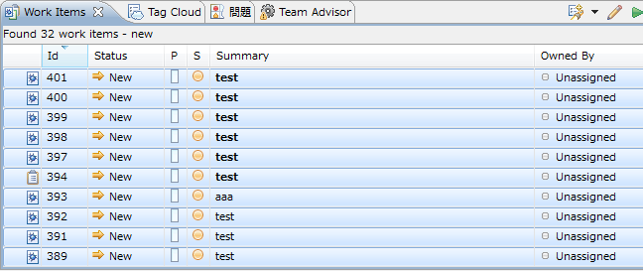ntext menu of first column in “Work Items” view.

right click

*If this feature is enabled during synchrozing attributes, existing work items will be numbered beginning at the top of “Work Items” view.

### Properties of this feature

#### Properties

##### Plugin common properties

###### Work Item Number attribute ID

Key Name:WORKITEM_NUMBER_ATTRIBUTE_KEY

Value: com.ibm.team.workitem.attribute.workItemNumber

In “Add Workitem Number attribute”, Work Item Number ID have to be set above value. If this ID is already used in your project area, you have to change the value of this property.

##### RTC Eclipse Client plugin

###### Number of digit

Key Name:WorkItemNumberingAspectEditor_NUMBER_OF_DIGIT_OPTIONS

Value: 5,10,15

If you want to change options for the number of digit, you change this property.

Note: Don’t set too long digit because Work Item Number Attribute is SmallString type(250byte in UTF-8).

###### Supporting Attribute type for numbering key

This feature uses work item query to search work item which has final Work Item Number.Some work item attributes is not supported for work item query. For instance, LargeString and LargeHtml is not supported. So, work item attributes which is set in this property is listed in “Configuration of target workitem types”.

In default configuration, “smallString”,”mediumString”,”timestamp” is set in this property. If you want to add other attribute types to numbering keys, change this property and re-install client plugin.

You can find the options of attribute types in process configuration source.

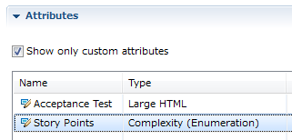If you want to add “Story Points” of “Story” work item in scrum template process to numbering key,

you have to find the customAttribute element which name is “Story Points” under “Story” work item category and get type attribute.

According to the above process configuration source, type attribute of “Story Points” is complexity, you have to add complexity to this property and re-install client plugin.

#### How to change properties

##### RTC Server plugin

Edit directly setting.properties in jar file of the server plugin by tools such as 7-zip

The path of setting.properties in the server plugin is as follows

\plugins\com.ibm.jp.ise.workitem.service_XXX.jar\com\ibm\jp.ise\workitem\service\process\setting.properties

##### RTC Eclipse Client plugin

The path of setting.properties in the server plugin is as follows

\com.ibm.jp.ise.workitem.ide.ui_XXX.jar\com\ibm\jp\ise\workitem\ide\ui\aspecteditor\settings.properties

### Hint&Tips

#### About the automatic numbering mechanism

##### In case of changing the work item type

In case of changing the work item type, it is numbered again by new work item type. In case of changeing the project area, do nothing

|  |  |  |  |
| --- | --- | --- | --- |
| ID | New/Change | Work Item Number | |
| Type A | Type B |
| 1 | New | 00001 | - |
| 2 | New | - | 00002 |
| 3 | New | - | 00003 |
| 4 | New | 00004 | - |
| 1 | Chage to B | ~~00001~~ | 00004 |
| 5 | New | 00005 | - |
| 6 | New | - | 00005 |
| 7 | New | 00006 | - |
| 8 | New | - | 00006 |
| 5 | Change to B | ~~00005~~ | 00007 |
| 6 | Change to A | 00007 | ~~00005~~ |
| 9 |  | 00008 | - |
| 10 |  | - | 00009 |

##### In case of changing custom attribute in numbering key

Custom attribute in numbering key is mutable anytime, but the work item number of existing work item isn’t numbered again.

#### About numbering of work item which was created before this feature was enabled

If this feature is disabled during “Synchronize additional attribute”, existing work item isn’t numberd at the time. However, existing work item is numbered when it is updated next time.